**UNIT - 1**

**Overview of AI (Artificial Intelligence)**

**Artificial Intelligence is** composed of two words **Artificial** and **Intelligence**, where Artificial defines "**man-made**," and intelligence defines "**thinking power**", hence AI means "**a man-made thinking power**."

Artificial Intelligence (AI) is a branch of computer science that focuses on **creating intelligent systems** capable of performing tasks that typically require human intelligence. These tasks include **learning, reasoning, problem-solving, perception and decision-making**.

**Key Aspects of AI:**

1. **Perception**: Understanding and interpreting the environment. This includes:

* **Computer Vision**: AI systems that analyze and interpret visual information from the world (e.g., facial recognition, object detection).
* **Speech Recognition**: Converting spoken language into text (e.g., voice assistants like Siri).

1. **Reasoning**: Drawing logical conclusions from available information. This is where AI often uses:

* **Logical Reasoning**: Involves algorithms that help systems reason logically based on given facts or rules.
* **Probabilistic Reasoning**: AI makes decisions based on probabilities when the data is uncertain or incomplete.

1. **Learning**: AI systems improve their performance over time as they process more data. This includes:

* **Supervised Learning**: The system learns from labeled data (e.g., training a model to predict house prices based on historical data).
* **Unsupervised Learning**: The system learns from data that is not labeled (e.g., clustering similar customers based on behavior).
* **Reinforcement Learning**: The system learns by performing actions and receiving feedback in the form of rewards or penalties (e.g., training a robot to navigate a maze).

1. **Decision Making**: AI makes decisions based on the reasoning and learning it performs. For example, autonomous vehicles make real-time decisions about navigation and collision avoidance.

**Types of AI Based on Capabilities:**

**1. Narrow AI (Weak AI)-**

Narrow AI is designed and trained on a specific task or a narrow range of tasks. These Narrow systems perform their designated tasks but mainly lack in the ability to generalize tasks. Narrow AI lacks the ability to function beyond its predefined scope. These systems do not possess understanding or awareness.

**Examples:**

* Voice assistants like **Siri** or **Alexa** that understand specific commands.
* **Facial recognition** software used in security systems.
* **Recommendation engines** used by platforms like Netflix or Amazon.

**2. General AI (Strong AI)-**

General AIrefers to AI systems that have human intelligence and abilities to perform various tasks. Systems have capability to understand, learn and apply across a wide range of tasks that are similar to how a human can adapt to various tasks. It requires the machine to have consciousness, self-awareness and the ability to make independent decisions, which is not yet achievable.

**Potential Applications:**

* Robots that can learn new skills and adapt to unforeseen challenges in real-time.
* AI systems that could autonomously diagnose and solve complex medical issues across various specializations.

**3. Superintelligence (Super AI)-**

Super AI surpasses intelligence of human in solving-problem, creativity and overall abilities. Super AI develops emotions, desires, need and beliefs of their own. They are able to make decisions of their own and solve problem of its own. It can revolutionize industries, scientific research, and problem-solving, possibly leading to unprecedented advancements.

**Types of Artificial Intelligence Based on Functionalities**

**1. Reactive Machines-**

Reactive machines are the most basic form of AI. They operate purely based on the present data and do not store any previous experiences or learn from past actions. These systems respond to specific inputs with fixed outputs and are unable to adapt.

**Examples:** IBM’s Deep Blue and Google’s AlphaGo.

**2. Limited Memory AI-**

Limited Memory AI can learn from past data to improve future responses. These systems use historical data to make decisions and predictions but do not have long-term memory. Machine learning models in autonomous systems and robotics often rely on limited memory to perform better.

**Examples:** Self-driving cars and Chatbots.

**3. Theory of Mind-**

Theory of Mind AI aims to understand human emotions, beliefs, intentions and desires. While this type of AI remains in development, it would allow machines to engage in more sophisticated interactions by perceiving emotions and adjusting behaviour accordingly.

**Examples:** Human-robot interaction and Collaborative robots.

**4. Self-Awareness AI-**

Self-Aware AI is an advanced stage of AI that possesses self-consciousness and awareness. This type of AI would have the ability to not only understand and react to emotions but also have its own consciousness, similar to human awareness.

**Examples:**

* Fully autonomous systems that can make moral and ethical decisions.
* AI systems that can independently pursue goals based on their understanding of the world around them.

**Problems in AI**

AI problems are usually framed in terms of tasks that need to be automated, and they can be divided into specific types based on the goals and constraints. The main problems AI aims to solve include:

1. **Classification Problems**: AI is used to categorize data into predefined classes or categories based on certain features.

* **Example**: Classifying emails as "spam" or "not spam"

1. **Regression Problems**: AI predicts continuous values based on input data.

* **Example**: Predicting the price of a stock or the temperature tomorrow.

1. **Clustering Problems**: AI groups data into clusters where data points in the same group are more similar to each other than to those in other groups.

* **Example**: Customer segmentation for targeted marketing strategies.

1. **Optimization Problems**: AI searches for the best possible solution within a large set of potential solutions.

* **Example**: Finding the most efficient route for delivery trucks in logistics.

1. **Search Problems**: These involve finding a solution in a complex problem space by exploring different possibilities.

* **Example**: Solving puzzles like the "8-puzzle" or planning a route on a map.

**Problem Space:**

The **problem space** defines all the **possible states and actions** that can occur while solving a problem. It is a representation of the problem where an agent (a system that solves the problem) starts at an initial state and works its way towards a goal state.

**Elements of Problem Space:**

1. **Initial State**: This is where the agent starts. It is the starting point of the solution.

* **Example**: In a navigation system, the initial state would be the starting location.

1. **Goal State**: This is the state the agent aims to reach. It represents the desired outcome or solution to the problem.

* **Example**: In a navigation system, the goal state is the destination point.

1. **Operators**: These are the actions or transitions that can move an agent from one state to another. Operators define what can be done to alter the state.

* **Example**: In a game like chess, operators would be the legal moves a player can make.

1. **State Space**: This is the collection of all possible states that the agent can reach. A large state space means a problem may require a lot of computational effort to find a solution.

* **Example**: In chess, the state space would include all possible board configurations.

**Searching Techniques:**

To find the solution within the problem space, AI uses **search algorithms**. These algorithms explore the state space and determine the most efficient way to reach the goal state.

**1) Uninformed (Blind) Search**:-

* **Breadth-First Search (BFS)**: This algorithm explores all possible states at one level before moving to the next level. It’s like a level-order traversal in a tree.
  + **Advantages**: It guarantees the shortest path in an unweighted graph.
  + **Disadvantages**: Can be memory-intensive as it stores all nodes in memory.
* **Depth-First Search (DFS)**: This algorithm explores as far as possible along one branch before backtracking.
  + **Advantages**: Memory-efficient (uses less memory).
  + **Disadvantages**: May not find the shortest path, and could get stuck in infinite loops.
* **Uniform Cost Search**: This is an extension of BFS, where it explores the least costly path first, not necessarily the shallowest.
  + **Advantages**: Finds the least-cost path when the cost is considered.

**2) Informed (Heuristic) Search**:-

* **A* Search**: This is a combination of BFS and heuristic search. It uses a cost function **f(n) = g(n) + h(n)** where g(n) is the cost from the start node to the current node, and h(n) is the estimated cost from the current node to the goal. It selects nodes based on the sum of actual and heuristic cost.
  + **Advantages**: It’s optimal and efficient when using a good heuristic function.
* **Greedy Best-First Search**: It selects the node with the lowest estimated cost to the goal (using only the heuristic).
  + **Advantages**: Can be faster but does not guarantee the shortest path.

**3) Local Search Algorithms**:-

* **Hill-Climbing**: This algorithm iteratively moves to the neighbor that has the highest value according to a given evaluation function. It’s a greedy approach and may get stuck in local maxima.
* **Simulated Annealing**: This algorithm allows random moves to avoid getting stuck in local maxima, simulating the cooling of a material to reach a global minimum.

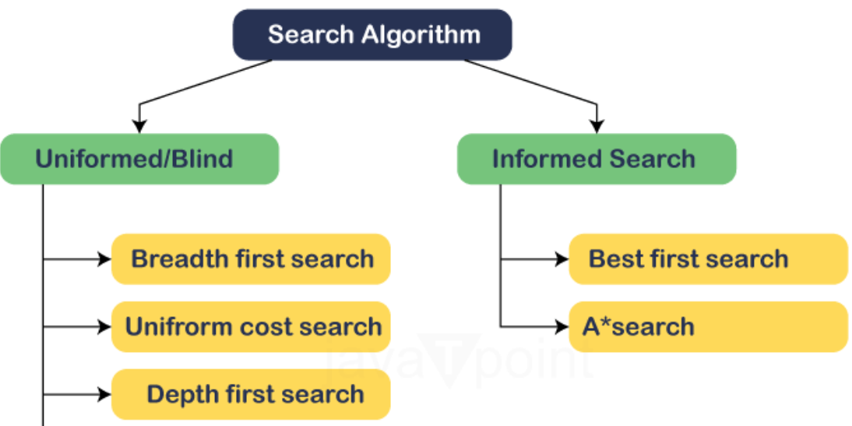

**Production Systems in AI**

A **Production System** is a **knowledge representation framework** that AI systems use to solve problems based on predefined rules. These systems are built around a set of **rules** that describe how knowledge is manipulated to derive conclusions.

**Components of a Production System:**

1. **Control Mechanism:** This governs the order in which rules are applied by the inference engine and manages the flow of the process. It ensures that the system responds appropriately to changes in the working memory and applies rules effectively to reach conclusions or solutions.
2. **Working Memory**: Sometimes referred to as the **fact list**, working memory holds the dynamic information that changes as the system operates. It represents the current state of knowledge, including facts that are initially known and those that are deduced throughout the operation of the system.
3. **Inference Engine**: The component that applies the rules to the current state (working memory) to infer new facts or take actions. It manipulates the working memory by matching conditions and executing corresponding actions.
4. **Knowledge Base**: This is the core repository where all the rules and facts are stored. In AI, the knowledge base is critical as it contains the **domain-specific information** and the **if-then rules** that dictate how decisions are made or actions are taken.

**Control Strategies: Forward and Backward Chaining**

**Control strategies** refer to the methods used to apply the rules in production systems. They determine the sequence and flow in which rules are applied and the strategy helps in directing the reasoning process towards a solution.

The two main types of control strategies / Production Systems are **Forward Chaining** and **Backward Chaining**.

**Forward Chaining**:

* **Definition**: Forward chaining is a **data-driven approach** where **reasoning begins with the available facts** and applies rules to infer new facts. It proceeds from the initial state and works towards the goal.
* **How It Works**:
  + It starts with the initial facts and applies rules whose conditions match the facts.
  + New facts are generated and added to the knowledge base (working memory).
  + The process continues until the goal is reached or no more rules can be applied.
* **Example**: In a medical diagnosis system, if the patient has a **fever** and a **cough**, the system can use forward chaining to infer the possible disease (e.g., flu).
* **Applications**: Used when the goal is not explicitly known in advance and the system needs to explore all possibilities by starting from known facts.

**Backward Chaining**:

* **Definition**: Backward chaining is a **goal-driven approach** where **reasoning starts with the goal and works backward** to find the conditions or facts that would lead to that goal.
* **How It Works**:
  + The process starts with the goal (what you want to achieve) and looks for rules that can satisfy that goal.
  + It checks if the conditions of these rules are true by recursively proving them (i.e., by working backward).
  + If the conditions are met, the goal is achieved. If not, the system continues searching for other rules or facts.
* **Example**: In a troubleshooting system, you start with the goal (e.g., fixing a broken car engine) and work backward by finding which parts could have failed and need replacement.
* **Applications**: Used in problem-solving scenarios where you have a specific goal and need to find the necessary steps or conditions to reach it.

**Heuristic Search Techniques**

Heuristic search methods **aim to improve the efficiency of search algorithms** by using additional information (heuristics) to guide the search process, reducing the number of possibilities explored.

**Hill Climbing**:

* **Definition**: Hill climbing is an iterative search algorithm that continuously moves towards the direction of the greatest improvement (the steepest hill).
* **How It Works**:
  + At each step, it **chooses the neighbor node with the highest value** according to an evaluation function (i.e., the steepest slope).
  + The process continues until no better neighbors are available, meaning a **local maximum or peak is reached**.
* **Advantages**: Simple and efficient for finding solutions quickly in problems where you have a clear and well-defined goal.
* **Disadvantages**:
  + **Local Maxima**: The algorithm may get stuck at a point where no better solutions exist, but the global best solution is still elsewhere.
  + **Plateaus**: The search might stall when all neighbors have the same value, making it hard to find a better solution.
* **Example**: Climbing a hill to reach the highest point (i.e., maximizing an objective function).

**Best-First Search**:

* **Definition**: Best-first search is an informed search algorithm that evaluates nodes using a heuristic function and expands the most promising nodes first.
* **How It Works**:
  + It uses a heuristic to rank the possible next states and chooses the one with the best heuristic value.
  + This search does not necessarily guarantee the optimal solution but explores the most promising path first.
* **Advantages**: Often faster than uninformed search techniques because it uses domain-specific knowledge to prioritize exploration.
* **Disadvantages**: It may not always find the optimal solution because it only considers heuristics, and no guarantee is provided for global optimality.
* **Example**: Pathfinding in a map where the system chooses the path based on proximity to the goal.

**A* Algorithm**:

* **Definition**: A* is a widely used search algorithm that combines the advantages of both **Best-First Search** and **Dijkstra’s Algorithm**. It evaluates nodes based on the sum of two components: the cost to reach the current node and the estimated cost to reach the goal.

The evaluation function is: **f(n) = g(n) + h(n)**

* **g(n)**: The cost from the start node to the current node.
* **h(n)**: The estimated cost from the current node to the goal (**heuristic**).
* **How It Works**:
  + A* uses both actual and heuristic costs to prioritize nodes.
  + It expands nodes that appear to be most promising based on the function f(n).
  + A* **guarantees the shortest path** if the heuristic is admissible (it does not overestimate the actual cost to reach the goal).
* **Advantages**: It is both **complete** (guaranteed to find a solution if one exists) and **optimal** (guaranteed to find the best path if the heuristic is admissible).
* **Disadvantages**: Can be computationally expensive if the state space is large.
* **Example**: Navigation systems use A* to find the shortest route from one location to another.

**AND/OR Graphs:**

**AND/OR Graphs** are used to represent problems where the solution requires multiple interdependent subproblems, either needing all or just some subproblems to be solved. They are often used in AI for decision-making and planning problems.

**AND/OR Graphs**:

* **AND Node**: This node represents a situation where **all** subproblems need to be solved to satisfy the goal.
* **Example**: To assemble a product, you must first solve several independent subproblems (e.g., assembling the engine, body, and wheels). All these subproblems must be solved to achieve the goal.
* **OR Node**: This node represents a situation where **only one** of several subproblems must be solved to achieve the goal.
* **Example**: In a game of chess, there might be several ways to win (checkmate the opponent in multiple ways). Any one of these paths can lead to success.

**How AND/OR Graphs Work**:

* **AND/OR Search**: The algorithm navigates through both AND nodes and OR nodes to find the solution. For an AND node, it ensures all subgoals are solved. For an OR node, it picks one subgoal to pursue.
* **Applications**: Used in planning and reasoning problems where certain conditions need to be met (AND nodes) while other conditions are alternative ways to reach a goal (OR nodes).
* **Example**: In AI planning (e.g., automated scheduling), a planner must consider both mandatory tasks (AND nodes) and alternative tasks (OR nodes) that can lead to a successful plan.

**UNIT - 2**

**Knowledge Representation in AI**

**Knowledge Representation (KR)** is a field of AI concerned with how knowledge about the world can be represented in a form that a computer system can utilize to solve complex tasks like reasoning, planning, learning, etc. It allows machines to simulate human understanding and decision-making. Effective KR must enable reasoning, adaptation, and problem-solving.

The two main types of knowledge representation are:

1. **Declarative Representation**: Specifies facts about the world (e.g., **Propositional Logic** and **Predicate Logic**).
2. **Procedural Representation**: Specifies the sequence of operations to achieve a task (e.g., **Production Systems**).

In AI, **logical formalisms** such as **Propositional Logic** and **Predicate Logic** are often used to represent knowledge, as they provide a structured, formal framework for reasoning.

**Propositional Logic (PL)**

**Propositional Logic** (also known as **Boolean Logic**) is a formal system used to represent simple statements, which can either be **true** or **false**. It forms the foundation for more complex logic systems and is widely used in reasoning and decision-making.

**Key Elements of Propositional Logic**:

* **Propositions**: A proposition is a statement that can either be true or false. It is often represented by a letter, e.g., **P**, **Q**, **R**.
* **Example**: "It is raining" can be represented as **P**.
* **Logical Connectives**: These are used to combine propositions to form more complex logical statements. The main connectives are:
* **AND ( ∧ )**: Both propositions must be true.
* **OR ( ∨ )**: At least one proposition must be true.
* **NOT ( ¬ )**: Inverts the truth value of a proposition.
* **IMPLIES ( → )**: If the first proposition is true, then the second proposition must also be true.
* **BICONDITIONAL ( ↔ )**: Both propositions must have the same truth value.
* **Truth Tables**: Propositional logic is evaluated using truth tables that show all possible truth values for combinations of propositions and their logical connectives.

**Limitations of Propositional Logic**:

* Propositional logic can only represent statements about objects, not relationships or properties of objects.
* It is not expressive enough for many real-world problems (e.g., reasoning about "all cars are red" requires more powerful logic).

**First-Order Predicate Logic (FOPL)**

**First-Order Predicate Logic** (also called **First-Order Logic** or **FOL**) is an extension of propositional logic and is far more powerful for representing complex knowledge. It allows the representation of statements involving variables, functions, and predicates.

**Key Elements of First-Order Predicate Logic**:

1. **Predicates**: Functions that take arguments and return a truth value. A predicate represents a property of an object or a relationship between objects.

* Example: Likes(John, IceCream) means "John likes ice cream."

1. **Constants**: Represent specific objects in the domain.

* Example: John is a constant representing a specific person.

1. **Variables**: Represent arbitrary elements in the domain.

* Example: Likes(x, IceCream) means "x likes ice cream," where x is a variable.

1. **Quantifiers**: Used to express general statements.

* **Universal Quantifier ( ∀ )**: Denotes that the statement is true for all instances of a variable.
  + Example: ∀x Likes(x, IceCream) means "Everyone likes ice cream."
* **Existential Quantifier ( ∃ )**: Denotes that there is at least one instance where the statement is true.
  + Example: ∃x Likes(x, IceCream) means "There exists at least one person who likes ice cream."

1. **Functions**: Functions map objects to other objects.

* Example: FatherOf(John) might refer to John's father.

1. **Logical Connectives**: The same as in propositional logic, such as AND, OR, NOT, IMPLIES, etc.

**Example**:

* "All humans are mortal" can be represented in FOPL as:
* ∀x (Human(x) → Mortal(x))

**Skolemization**

**Skolemization** is a process used in converting a formula in first-order logic to **Skolem normal form** to eliminate existential quantifiers. It’s typically used when converting formulas to a form suitable for automated theorem proving.

**Why Skolemization?**

In FOPL, quantifiers (especially existential quantifiers) introduce variables that depend on other variables. Skolemization replaces existentially quantified variables with **Skolem functions** to remove dependencies, thus making the formula easier to manipulate in automated reasoning.

**How Skolemization Works**:

* If you have a formula like ∃y ∀x P(x, y), Skolemization removes the existential quantifier by replacing y with a Skolem function, say f(x). The resulting formula is ∀x P(x, f(x)).
* In the case where the existential quantifier does not depend on any universal quantifiers, the Skolem function becomes a constant.

**Example**:

* Original: ∃y ∀x Likes(x, y)
* After Skolemization: ∀x Likes(x, f(x)) where f(x) is a Skolem function.

**Resolution Principles and Unification**

**Resolution** is a fundamental inference rule used in logic-based AI systems to prove the validity of a logical expression. It is widely used in **automated theorem proving** and **logic programming** (e.g., Prolog).

**Resolution**:

* **Resolution** is a method used to derive a contradiction from a set of clauses (conjunctive normal form, CNF).
* A **clause** is a disjunction (OR) of literals (variables or their negations), e.g., (P ∨ ¬Q).
* The resolution rule combines two clauses to produce a new clause, where a pair of complementary literals (e.g., P and ¬P) is eliminated.

**Resolution Rule**:

* Given two clauses: (P ∨ Q) and (¬P ∨ R), you can resolve them to produce (Q ∨ R).

**Unification**:

* **Unification** is the process of making two logical expressions identical by finding a substitution for the variables. It is a key step in the resolution process.
* **Unification** involves matching terms or predicates in logical expressions. A substitution is a set of variable mappings that make the terms identical.
* Example: Unifying Likes(x, IceCream) with Likes(John, y) results in the substitution {x/John, y/IceCream}.
* **Example of Resolution**:
* Clauses: (Human(x) ∨ ¬Mortal(x)) and (¬Human(x) ∨ Mortal(x))
* Unify Human(x) with ¬Human(x), resolve to yield Mortal(x) ∨ Mortal(x).

**Horn Clauses**

A **Horn Clause** is a special type of clause in propositional or first-order logic where at most one literal is positive (i.e., not negated).

Horn clauses are very useful in logic programming, particularly in **Prolog**.

**Structure of Horn Clause**:

* A Horn clause is of the form:
* L1 ∨ L2 ∨ ... ∨ Ln → L where L is a positive literal, and L1, L2, ..., Ln are negative literals.
* In simpler terms, it means if L1, L2, ..., Ln are true, then L must also be true.

**Example**:

* ¬Human(x) ∨ Mortal(x) → Immortal(x) (If x is not human, and x is mortal, then x is immortal).
* **Horn Clauses in Prolog**: Prolog uses Horn clauses to represent knowledge. Each clause represents a rule, and Prolog’s inference engine uses these rules to derive conclusions.

**Importance**:

* Horn clauses are computationally efficient because they can be evaluated in linear time.
* They are particularly useful for representing **facts** and **rules** in knowledge-based systems and logic programming.

**Summary**

1. **Propositional Logic**:

* Deals with simple statements that can either be true or false, using logical connectives.

1. **First-Order Predicate Logic**:

* Extends propositional logic by introducing predicates, variables, and quantifiers, allowing for more expressive knowledge representation.

1. **Skolemization**:

* A technique to eliminate existential quantifiers in first-order logic, making it easier to process and reason with.

1. **Resolution and Unification**:

* **Resolution** is a rule of inference used in automated theorem proving.
* **Unification** is the process of making two logical terms identical by finding the right substitution for variables.

1. **Horn Clauses**:

* A specific type of clause used in logic programming and AI. They are efficient for automated reasoning and used in systems like Prolog.

These logical frameworks are the foundation for representing knowledge, reasoning, and problem-solving in AI systems.

Certainly! Below is a comprehensive explanation of **Expert Systems** (ES), including their **introduction**, **components**, **development process**, **learning**, **planning**, **explanation** in expert systems, and a study of **MYCIN** and **AM** expert systems.

**Expert System: Introduction**

An **Expert System (ES)** is an AI application designed to emulate the decision-making ability of a human expert in a specific domain. It uses a knowledge base of human expertise and an inference engine to solve complex problems within a particular field, such as medical diagnosis, engineering, or troubleshooting.

**Key Features of Expert Systems**:

* **Knowledge Base**: Contains domain-specific knowledge in the form of facts, rules, and heuristics.
* **Inference Engine**: Applies logical rules to the knowledge base to derive conclusions or solutions.
* **User Interface**: Allows interaction between the system and the user, providing responses and explanations.
* **Explanation System**: Provides explanations of the reasoning behind the system’s conclusions, making it transparent and understandable.

**Expert systems** aim to assist or replace human experts in decision-making tasks by offering solutions based on knowledge and reasoning.

**Components of an Expert System**

An expert system typically consists of the following key components:

1. **Knowledge Base**:

* The knowledge base is a structured collection of information, rules, facts, and heuristics in the form of **if-then** rules (production rules) or **frames** (structured knowledge).
* It stores **domain-specific knowledge** (e.g., medical knowledge for diagnosis) and can include both declarative knowledge (facts) and procedural knowledge (rules for action).

1. **Inference Engine**:

* The inference engine is the core of the expert system. It applies reasoning techniques to the knowledge base to draw conclusions, make decisions, or solve problems.
* There are two main types of reasoning techniques:
  + **Forward Chaining**: Starts with known facts and applies rules to reach conclusions (data-driven approach).
  + **Backward Chaining**: Starts with a goal and works backward to find the facts needed to achieve that goal (goal-driven approach).

1. **User Interface**:

* The user interface enables interaction with the expert system. It provides the means for users to input queries and receive solutions or advice.
* It also facilitates communication between the user and the system, such as displaying questions or explaining reasoning steps.

1. **Explanation System**:

* The explanation system allows the expert system to explain its reasoning to the user. It helps in justifying decisions and improves user trust in the system.
* It can explain why certain facts were considered or how a solution was reached.

1. **Knowledge Acquisition**:

* Knowledge acquisition involves gathering and updating the knowledge base, usually from human experts or documentation.
* This process is critical for keeping the system up to date and relevant.

1. **Knowledge Engineer**:

* The knowledge engineer is responsible for designing and maintaining the expert system by encoding the domain knowledge into a machine-readable format.
* They also update and modify the knowledge base as the domain knowledge evolves.

**Development Process of an Expert System**

Developing an expert system involves several phases to create a system that can provide expert-level decision-making or problem-solving:

1. **Problem Identification**:

* The first step is to identify the specific problem that the expert system will address, whether it's in fields like healthcare, finance, or troubleshooting.

1. **Knowledge Acquisition**:

* In this phase, knowledge engineers work with domain experts to gather relevant knowledge and insights that will form the knowledge base of the system.
* Knowledge can be acquired through interviews, documents, case studies, and observations.

1. **Knowledge Representation**:

* The acquired knowledge is then structured in a way that can be processed by the system. This can involve using **rules**, **frames**, or **semantic networks**.

1. **Inference Engine Development**:

* The inference engine is programmed to apply reasoning techniques like forward or backward chaining to infer conclusions from the knowledge base.

1. **System Design**:

* The system’s architecture, including the user interface, reasoning mechanisms, and explanation features, is designed.

1. **Testing and Validation**:

* The expert system is tested using real-world scenarios or sample problems. Feedback from domain experts is used to validate the system’s accuracy and effectiveness.

1. **Deployment and Maintenance**:

* The system is deployed for use in the target domain. Ongoing maintenance is necessary to update the knowledge base, improve performance, and adapt to changing requirements.

**Learning in Expert Systems**

Learning in expert systems refers to the system’s ability to improve over time, either by acquiring new knowledge, refining its rules, or adapting to changes in the problem domain.

**Types of Learning**:

1. **Supervised Learning**:

* The expert system is trained using a set of input-output pairs. The system learns to associate specific inputs with correct outputs.

1. **Unsupervised Learning**:

* The system tries to identify patterns or relationships in the data without any predefined outputs, often used for clustering or classification tasks.

1. **Reinforcement Learning**:

* The system learns through trial and error, receiving feedback based on its actions. It aims to maximize long-term rewards or performance.

1. **Knowledge Refinement**:

* As the expert system interacts with users or receives feedback, the knowledge base can be refined and updated to improve the accuracy of the system’s conclusions.

**Planning in Expert Systems**

**Planning** in expert systems refers to the process of creating a sequence of actions to achieve a specific goal, considering constraints and available resources. In domains like robotics, automated scheduling, and logistics, expert systems are used to generate plans and solutions for complex tasks.

**Steps in Planning**:

1. **Goal Definition**:

* The first step is clearly defining the goal the system is aiming to achieve.

1. **Problem Decomposition**:

* The goal is broken down into smaller subgoals or tasks that can be more easily tackled.

1. **Resource Allocation**:

* Identifying the resources (time, tools, human expertise, etc.) needed to achieve the plan and ensure success.

1. **Action Selection**:

* Based on the knowledge base and constraints, the expert system selects actions or decisions that move towards the goal.

1. **Plan Execution**:

* The chosen plan is executed, with continuous monitoring to adjust and revise the plan as necessary.

**Explanation in Expert Systems**

Explanation is a key feature in expert systems, particularly in critical domains like healthcare, where users need to understand how conclusions are reached.

**Purpose of Explanation**:

* **Transparency**: Explains the reasoning process to users, making the system more understandable and trustworthy.
* **Learning**: Helps users learn from the system’s reasoning process and improves their understanding of the problem domain.
* **Debugging**: Assists in troubleshooting by clarifying why certain decisions or actions were taken.

**How Explanation Works**:

* **Rule-based explanation**: Explains conclusions by showing which rules were triggered during the reasoning process.
* **Case-based explanation**: Describes how the system’s conclusions are similar to previous cases or examples.

**Study of Existing Expert Systems: MYCIN & AM**

**MYCIN**:

* **MYCIN** is an early expert system developed in the 1970s for diagnosing bacterial infections and recommending antibiotic treatments.
* **Components**:
* **Knowledge Base**: Contained rules about infections, symptoms, and treatments.
* **Inference Engine**: Used backward chaining to make conclusions based on symptoms provided by the user.
* **User Interface**: Physicians could input patient symptoms and get diagnostic suggestions.
* **Strength**: MYCIN performed well in diagnosing infections and was able to match or surpass human experts in accuracy.
* **Weakness**: Its domain was limited, and it did not provide detailed explanations about the reasoning behind its suggestions.

**AM (Analogy-Making)**:

* **AM** is an expert system developed for problem-solving using analogies. It was designed to make inferences and draw conclusions based on previously encountered problems.
* **Components**:
* **Knowledge Base**: Contains previous cases or examples of problems and solutions.
* **Inference Engine**: Makes decisions by finding analogies between the current problem and past cases.
* **User Interface**: Users input a new problem, and the system finds a similar past case to suggest a solution.
* **Strength**: AM was powerful in solving complex problems that had a similar past analogy.
* **Weakness**: Its effectiveness depended heavily on the availability of relevant cases.

**Summary**

1. **Expert System**: AI systems designed to mimic human expertise in specific domains, solving complex problems using a knowledge base and inference engine.
2. **Components**: Knowledge base, inference engine, user interface, explanation system, and knowledge acquisition.
3. **Development Process**: Involves problem identification, knowledge acquisition, system design, testing, deployment, and maintenance.
4. **Learning and Planning**: Expert systems can learn from feedback and plan sequences of actions to achieve goals.
5. **Explanation**: Provides transparency by explaining the reasoning behind conclusions to users.
6. **MYCIN and AM**: Both were early expert systems used for medical diagnosis and analogy-making, respectively. MYCIN was highly effective in diagnosing bacterial infections, while AM used analogies to solve problems.

Expert systems have evolved significantly and remain a powerful tool for decision support and problem-solving in various domains.

**UNIT - 3**

**Machine Learning**

Machine Learning (ML) is a *branch of Artificial Intelligence (AI)* that enables systems to **automatically learn from data, identify patterns and make decisions with minimal human intervention**. It involves building models using algorithms that can **predict outcomes** or **identify patterns** *based on input data*.

Machine Learning (ML) systems improve their performance over time by learning from new data *without explicit programming*. It is widely applied in fields like healthcare, finance, e-commerce and autonomous systems for tasks such as diagnosis, recommendation systems, fraud detection and self-driving vehicles.

**Types of Machine Learning**

1. Supervised Learning
2. Unsupervised Learning
3. Semi-Supervised Learning
4. Reinforcement Learning

**Supervised Learning**

Supervised learning is a type of machine learning where models are trained using labeled data, meaning each input has a corresponding correct output. The algorithm learns by comparing predictions with actual results to minimize error.

**Characteristics:**

* Requires labeled data for training.
* Goal is to map input to output accurately.
* Can be used for classification and regression problems.

**Examples:**

* Spam detection in emails.
* Predicting house prices.
* Handwritten digit recognition.

**Algorithms:**

* Linear & Logistic Regression
* Support Vector Machines (SVM)
* Decision Trees

**Unsupervised Learning**

It involves training models using unlabeled data. The algorithm explores the data to identify hidden patterns, clusters or associations without predefined labels.

**Characteristics:**

* No labeled data is required.
* Goal is to find structure or patterns within data.
* Often used for clustering and association problems.

**Examples:**

* Customer segmentation in marketing.
* Anomaly detection in network security.
* Market basket analysis.

**Algorithms:**

* K-Means Clustering
* Principal Component Analysis (PCA)
* Hierarchical Clustering

**Semi-Supervised Learning**

Semi-supervised learning is a hybrid approach that uses **both labeled and unlabeled data** for training. It **combines the strengths of supervised and unsupervised learning**, making it effective *when labeled data is scarce*.

**Characteristics:**

* Uses a small amount of labeled data and a large amount of unlabeled data.
* Cost-effective as labeling data can be expensive.
* Useful when data labeling is time-consuming.

**Examples:**

* Speech recognition systems.
* Medical diagnosis with limited labeled samples.
* Fraud detection.

**Algorithms:**

* Self-training
* Co-training
* Graph-based Models

**Reinforcement Learning**

It involves training models through interactions with an environment. The algorithm learns by performing actions and receiving rewards or penalties based on its performance.

**Characteristics:**

* Learns through trial-and-error.
* Goal is to maximize cumulative rewards.
* Commonly used for decision-making tasks.

**Examples:**

* Autonomous vehicles.
* Robotics and industrial automation.
* Game-playing AI (e.g., AlphaGo).

**Algorithms:**

* Q-Learning
* Deep Q Networks (DQN)
* SARSA

**Comparison of Supervised, Unsupervised and Reinforcement Learning**

| **Basis** | **Supervised Learning** | **Unsupervised Learning** | **Reinforcement Learning** |
| --- | --- | --- | --- |
| **Training Data** | Uses labeled data. | Uses unlabeled data. | Uses an agent that interacts with the environment and learns from feedback. |
| **Feedback** | Takes direct feedback to check correctness. | No feedback is provided. | Learns from rewards and punishments. |
| **Objective** | Predicts the output. | Finds hidden patterns in data. | Maximizes rewards by taking the best possible actions. |
| **Input and Output** | Input data is provided along with the output. | Only input data is provided. | Learns by interacting with the environment and receiving feedback. |
| **Goal** | Train the model to predict outputs for new data. | Discover hidden structures and insights from data. | Train an agent to take optimal actions for maximum cumulative rewards. |
| **Supervision** | Needs supervision. | No supervision needed. | No direct supervision, but feedback is given via rewards/punishments. |
| **Categories** | Classification and Regression problems. | Clustering and Association problems. | Model-based and Model-free learning (Q-Learning, Deep Q-Networks). |
| **Application Scope** | Used when both input and output are available. | Used when only input is available. | Used in decision-making problems where actions impact future rewards. |
| **Accuracy** | Produces accurate results. | May give less accurate results. | Accuracy depends on the agent's learning strategy and exploration. |
| **Relation to AI** | **Less close to AI** as it requires labeled training data. | **More close to AI** as it learns like humans from patterns. | **Closest to AI** as it learns through trial and error like humans. |
| **Algorithms** | Linear Regression, Logistic Regression, SVM, Decision Tree, Multi-class Classification, Bayesian Logic etc. | Clustering, KNN, Apriori Algorithm, etc. | Q-Learning, Deep Q-Networks (DQN), Policy Gradient Methods. |

**Data Source**

A **data source** refers to the origin from which data is collected for analysis, processing and machine learning model training.

Data can come from various **structured**, **semi-structured** **or** **unstructured formats**.

**Types of Data Sources:**

1. **Primary Data Source:**
   * Data collected directly from **first-hand sources**.
   * Example: Surveys, Interviews, Experiments.
2. **Secondary Data Source:**
   * Data collected from **existing records or datasets**.
   * Example: Government Reports, Market Research Reports, Online Databases.
3. **Structured Data Source:**
   * Organized data stored in relational databases (**rows and columns**).
   * Example: SQL Databases, Spreadsheets.
4. **Unstructured Data Source:**
   * Data without a predefined format, often **text**, **images** or **videos**.
   * Example: Social Media Posts, Video Files, Sensor Data.
5. **Streaming Data Source:**
   * **Continuous data flow** generated in **real-time**.
   * Example: IoT Devices, Financial Market Feeds.

**Curse of Dimensionality**

The **Curse of Dimensionality** refers to the **challenges and problems** that arise when dealing with datasets having a large number of features (dimensions).

As the number of dimensions increases, data becomes sparse, making analysis difficult.

**Problems Due to Curse of Dimensionality:**

1. **Increased Computational Complexity:**
   * Higher dimensions lead to exponential growth in computations.
2. **Overfitting:**
   * Models may overfit due to too many irrelevant or redundant features.
3. **Sparsity of Data:**
   * Data points become sparsely distributed, making clustering and classification harder.
4. **Distance Metrics Fail:**
   * Traditional distance-based algorithms like k-NN and k-Means lose effectiveness as distances become less meaningful in high dimensions.
5. **Visualization Issues:**
   * Data visualization becomes nearly impossible in high-dimensional space.

**Overview of Dimension Reduction**

**Dimension Reduction** is the process of **reducing the number of features (dimensions)** in a dataset while retaining the most important information.

It helps to **overcome the curse of dimensionality** by simplifying datasets.

**Objectives of Dimension Reduction:**

* Improve model performance.
* Reduce computational cost.
* Enhance data visualization.
* Mitigate overfitting.

**Types of Dimension Reduction Techniques:**

**1. Feature Selection:**

* Selects the most relevant features using methods like **correlation analysis** or **information gain**.
* Methods:
  + Filter Methods (e.g., Chi-Square Test, Correlation Coefficient)
  + Wrapper Methods (e.g., Recursive Feature Elimination)
  + Embedded Methods (e.g., Lasso Regression)

**2. Feature Extraction:**

* Transforms high-dimensional data into a lower-dimensional space.
* Methods:
  + Principal Component Analysis (PCA)
  + Linear Discriminant Analysis (LDA)
  + t-Distributed Stochastic Neighbor Embedding (t-SNE)

**3. Manifold Learning:**

* A non-linear technique used for reducing dimensions while preserving local data structure.
* Methods:
  + Isomap
  + Locally Linear Embedding (LLE)
  + Multidimensional Scaling (MDS)

**Applications of Dimension Reduction:**

* Image compression using PCA.
* Data visualization for large datasets.
* Speeding up machine learning algorithms.
* Noise removal in data preprocessing.

**Principal Component Analysis (PCA)**

**Definition:**

* PCA is a **dimensionality reduction** technique used to reduce the number of features in a dataset while retaining as much information as possible.
* It transforms correlated features into a set of uncorrelated features called **Principal Components (PCs)**.

**Steps in PCA:**

1. **Standardization:**
   * Normalize the dataset to have mean = 0 and variance = 1.
2. **Compute the Covariance Matrix:**
   * Measure how features vary with respect to each other.
3. **Calculate Eigenvalues and Eigenvectors:**
   * ***Eigenvectors*** represent the **direction of the new feature space**.
   * ***Eigenvalues*** represent the **magnitude or importance of these directions**.
4. **Select Principal Components:**
   * Choose the top **k** eigenvectors with the highest eigenvalues.
5. **Form the New Dataset:**
   * Project the original data onto the selected principal components to obtain the reduced dataset.

**Applications of PCA:**

* Image Compression
* Noise Reduction
* Pattern Recognition
* Data Visualization
* Feature Extraction for Machine Learning

**Advantages of PCA:**

* Reduces computational cost by lowering dimensions.
* Removes redundancy by eliminating correlated features.
* Improves model performance in some cases.

**Disadvantages of PCA:**

* Loss of interpretability since original features are transformed.
* Sensitive to data scaling.
* Not effective for non-linear datasets.

**UNIT - 4**

**Supervised Learning**

Supervised learning is a machine learning approach where the algorithm is trained using **labeled data**. The model learns the relationship between input features (independent variables) and output labels (dependent variables) and uses this understanding to predict outcomes for new data.

Supervised learning is broadly divided into two categories:

1. **Regression** - Predicts continuous values.
2. **Classification** - Predicts discrete class labels.

**Regression**

Regression is used to predict continuous numerical values based on input features.

It is applied when the output variable is a real or continuous number like **temperature, salary or sales**.

**Key Features:**

* Predicts numerical outputs.
* Establishes a relationship between dependent and independent variables.
* Best suited for understanding trends or making quantitative predictions.

**Examples:**

* Predicting the price of a house based on size and location.
* Estimating sales revenue for a company.
* Forecasting temperature changes.

**Linear Regression**

Linear Regression is one of the simplest forms of regression. It assumes a linear relationship between the **independent variable X** and the **dependent variable Y**.

It tries to fit a straight line through the data points such that the difference between actual and predicted values is minimized.

**Equation of Linear Regression:**

Y = mX + c

Where:

* Y = Predicted Output
* X = Input Variable
* m = Slope of the Line
* c = Intercept

**Cost Function:**

Linear regression uses **Mean Squared Error (MSE)** to evaluate the model's performance:

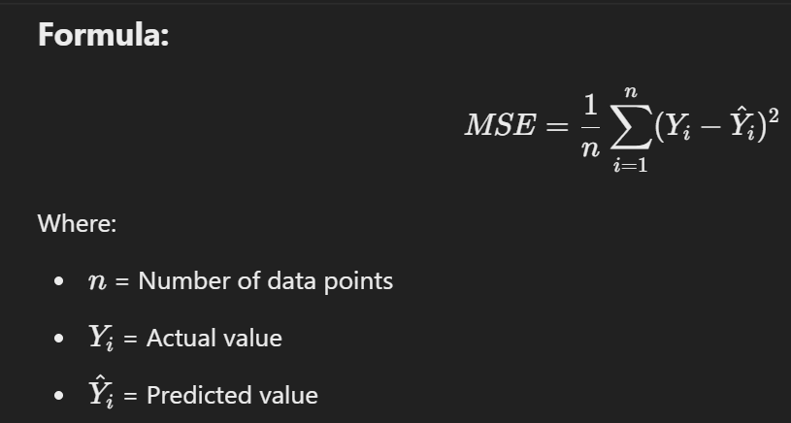

**Characteristics:**

* Easy to interpret and implement.
* Sensitive to outliers.
* Assumes linearity in data.

**Applications:**

* Predicting stock prices.
* Estimating the growth of a business.
* Predicting weather patterns.

**Classification**

Classification is a supervised learning technique used to predict a categorical class label.

It is used when the output is discrete or falls into specific categories like **Spam or Not** **Spam**, **Yes or No** or classifying different species of animals.

**Key Features:**

* Predicts discrete outputs.
* Models decision boundaries for classification.
* Can handle both binary and multi-class classification.

**Examples:**

* Identifying emails as spam or not spam.
* Classifying medical images as cancerous or non-cancerous.
* Predicting loan approval based on customer data.

**Logistic Regression**

Logistic Regression is a classification algorithm used to predict the probability of a categorical dependent variable. **Unlike linear regression**, it uses a logistic (sigmoid) function to map predictions to probabilities ranging from 0 to 1.

**Sigmoid Function:**

The Sigmoid Function is a mathematical function that produces an output between 0 and 1, making it useful for binary classification tasks. It is commonly used in logistic regression and neural networks.

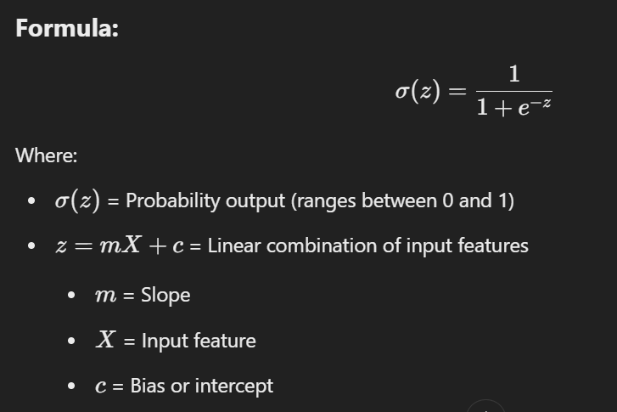

**Equation for Logistic Regression:**

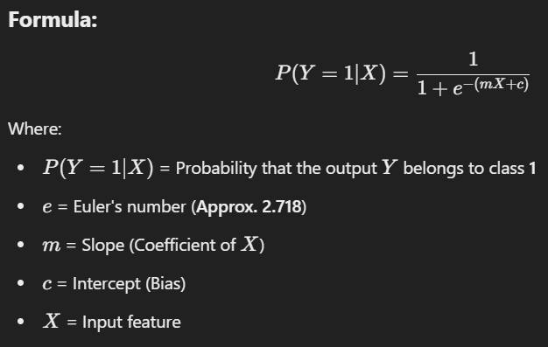

**Decision Boundary:**

* If the output is **> 0.5** → Class 1 (Positive Class)
* If the output is **≤ 0.5** → Class 0 (Negative Class)

**Characteristics:**

* Suitable for binary and multi-class classification.
* Provides probability scores for predictions.
* Sensitive to feature scaling.

**Applications:**

* Cancer diagnosis based on medical test results.
* Fraud detection in banking.
* Credit score prediction.

**Support Vector Machines (SVM)**

Support Vector Machines (SVM) is a **powerful classification algorithm** that works by finding the **optimal hyperplane** that best separates data points of different classes.

The **goal** is to **maximize the margin**, which is the distance between the **hyperplane** and the nearest data points, known as **support vectors**.

**Key Components of SVM:**

* **Hyperplane:** The decision boundary that separates different classes.
* **Support Vectors:** Data points closest to the hyperplane that define its position.
* **Margin:** The distance between the hyperplane and the nearest support vectors.

**Equation of Hyperplane:**

w⋅X + b = 0

Where:

* w = Weight vector
* X = Feature vector
* b = Bias

**Kernel SVM:**

Kernel SVM is an **extension** of the standard Support Vector Machine (SVM) that uses kernel functions to handle non-linear data by transforming it into a higher-dimensional space where a linear separation is possible.

**Why Use Kernel SVM?**

* When data is not linearly separable in its original space, Kernel SVM projects it into a higher-dimensional space using a mathematical function called a kernel.
* This makes it easier to find a linear hyperplane for classification.

Common Kernels:

* **Linear Kernel** - For linearly separable data.
* **Polynomial Kernel** - For non-linear data.
* **Radial Basis Function (RBF) Kernel** - Effective for complex patterns.

**Characteristics:**

* Effective for both linear and non-linear classification.
* Works well with high-dimensional data.
* Sensitive to choice of kernel and regularization.

**Applications:**

* Image classification.
* Face recognition.
* Bioinformatics (e.g., gene classification).

**Comparison Table: Linear Regression, Logistic Regression and Support Vector Machines**

| **Basis** | **Linear Regression** | **Logistic Regression** | **Support Vector Machines (SVM)** |
| --- | --- | --- | --- |
| **Type** | Regression | Classification | Classification |
| **Output** | Continuous Value | Probability of Class | Class Labels (Binary or Multi-class) |
| **Function Used** | Linear Function | Sigmoid Function | Hyperplane and Kernel Functions |
| **Objective** | Minimize Mean Squared Error (MSE) | Minimize Log Loss | Maximize Margin |
| **Handling Non-linearity** | Poor for non-linear data | Moderate, works with non-linear boundaries | Excellent using Kernel Trick |
| **Interpretability** | Easy to interpret | Moderate interpretability | Hard to interpret in higher dimensions |
| **Applications** | House Price Prediction | Disease Diagnosis, Fraud Detection | Image Recognition, Bioinformatics |
| **Performance on Noise** | Sensitive to noise | Sensitive to Outliers | Less sensitive with appropriate kernel choice |
| **Computational Complexity** | Low for small data sets | Low to Moderate | High for large and complex data sets |

**Bayes Classifiers**

Bayes Classifiers are probabilistic models used for classification tasks. They apply **Bayes’ Theorem** to predict the likelihood of a particular class based on given input data.

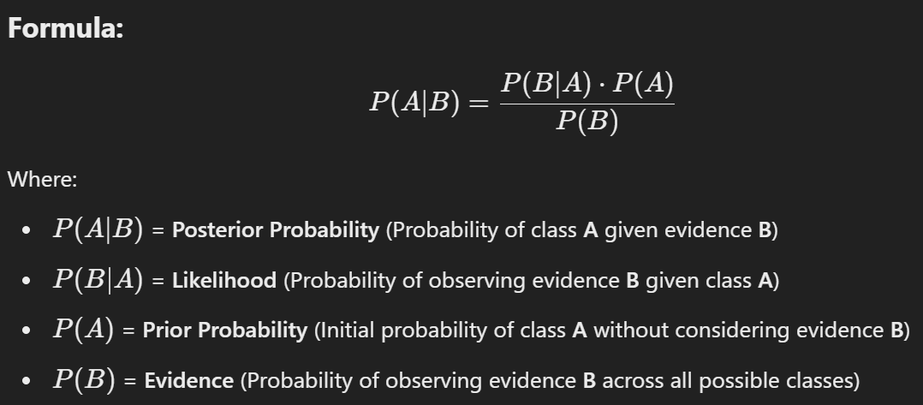

**Types of Bayes Classifiers:**

1. **Naive Bayes Classifier:**
   * Assumes that features are independent (Naive assumption).
   * Works well for large datasets.
   * Best suited for text classification like spam detection or sentiment analysis.
2. **Gaussian Naive Bayes:**
   * Assumes the continuous data follows a normal distribution.
   * Used for applications like medical diagnosis and image recognition.
3. **Multinomial Naive Bayes:**
   * Suitable for document classification problems with word count data.
   * Applied in sentiment analysis and news categorization.
4. **Bernoulli Naive Bayes:**
   * Designed for binary/boolean feature data.
   * Example: Email classification (Spam or Not Spam).

**Advantages:**

* Efficient for high-dimensional data.
* Requires less computational power.
* Performs well for text classification.

**Disadvantages:**

* Assumption of feature independence is rarely true.
* Sensitive to irrelevant features.

**Decision Trees**

A Decision Tree is a supervised learning model that uses a tree-like structure to make decisions. It is built by splitting data into subsets based on feature values, leading to a series of decision nodes and leaf nodes representing class labels or regression values.

**Structure of a Decision Tree:**

* **Root Node:** The top node representing the entire dataset.
* **Decision Nodes:** Nodes where the data is split based on a decision rule.
* **Leaf Nodes:** Nodes representing the output or prediction.

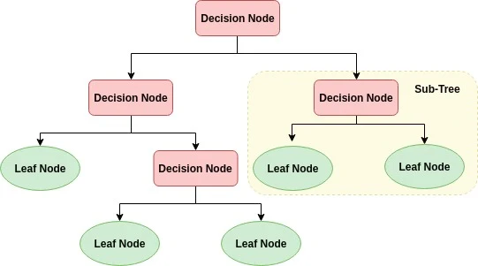

**Splitting Criteria:**

Decision Trees use mathematical functions to decide the best split at each node. The most common splitting criteria are:

**1. Gini Index**

Gini = 1 − ∑(pi)

where pi = Probability of a class in the dataset

**Key Points:**

* Measures **impurity** or how often a randomly chosen element would be incorrectly classified.
* A **lower Gini Index** indicates a better split.
* Gini Index is generally used in **Classification and Regression Trees (CART)**.

**2. Entropy and Information Gain**

**Entropy Formula:**

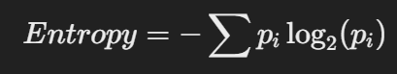

where pi = Probability of a class in the dataset

**Key Points:**

* Entropy measures the **randomness** or uncertainty in the dataset.
* A **higher entropy** means the data is more disordered.
* A **lower entropy** means the data is purer.

**Information Gain Formula:**

**Information Gain = Entropy (Parent) − Weighted Sum of Entropy (Children)**

**Key Points:**

* Measures the **reduction in entropy** after splitting the dataset.
* Higher Information Gain indicates a better split.
* Used in algorithms like **ID3** and **C4.5**.

**Advantages:**

* Simple and easy to interpret.
* Requires little data preprocessing.
* Handles both numerical and categorical data.

**Disadvantages:**

* Prone to overfitting if the tree is too deep.
* Sensitive to noisy data.

**Techniques to Prevent Overfitting:**

* **Pruning:** Remove unnecessary branches.
* **Limiting Tree Depth:** Restrict maximum depth.
* **Minimum Split Size:** Set a threshold for data splits.

**Ensemble Learning**

Ensemble Learning is a technique in machine learning where multiple models (often called weak learners or base models) are combined to improve accuracy and robustness.

It helps to reduce overfitting and increases generalization performance by leveraging the strengths of different models.

**Instead of relying on a single model**, ensemble learning aggregates multiple predictions to produce a more accurate result.

**Types of Ensemble Learning:**

**1. Bagging (Bootstrap Aggregating)**

**Bagging** is an ensemble method that reduces variance by **training multiple independent models in parallel** using different subsets of the data. It is especially useful for high-variance models like **Decision Trees**.

**How Bagging Works:**

1. **Bootstrap Sampling:**
   * Multiple random subsets (**bootstrapped samples**) are created by sampling **with replacement** from the original dataset.
2. **Model Training:**
   * Each subset is used to train a separate model independently.
3. **Prediction Combination:**
   * For **classification**, predictions are combined using **majority voting**.
   * For **regression**, predictions are averaged.

**Example of Bagging: Random Forest**

* **Random Forest** is a widely used bagging algorithm.
* It trains multiple decision trees on different data subsets and averages their predictions to minimize overfitting.
* **More trees** lead to more stable and accurate predictions.

**Use Case:** Predicting whether a customer will default on a loan using multiple decision trees to get reliable predictions.

**Advantages of Bagging:**

* **Reduces Overfitting:** Lowers variance by averaging predictions.
* **Stable and Accurate:** Less sensitive to noise and variations in data.
* **Works with Complex Models:** Performs well with high-variance models like Decision Trees.

**Disadvantages of Bagging:**

* **No Bias Reduction:** It focuses on reducing variance, not bias.
* **Resource Intensive:** Training multiple models can be computationally expensive.

**2. Boosting**

**Boosting** is a sequential ensemble method that reduces bias by **training models in a step-by-step manner**. Each subsequent model corrects the errors made by the previous one, making the overall prediction stronger.

**How Boosting Works:**

1. **Initial Model Training:**
   * A weak model (e.g., Decision Tree) is trained on the dataset.
2. **Error Focus:**
   * Misclassified samples are given **higher weights** to ensure the next model focuses on them.
3. **Iteration:**
   * This process repeats until no significant improvement is observed.
4. **Final Prediction:**
   * Predictions from all models are combined using a **weighted sum**.

**Examples of Boosting:**

1. **AdaBoost (Adaptive Boosting):**
   * Focuses on correcting misclassified data points in each iteration.
2. **XGBoost (Extreme Gradient Boosting):**
   * More efficient than AdaBoost using gradient-based optimization.
   * Handles missing data and large datasets effectively.

**Use Case:** Fraud detection in banking, where misclassifications are iteratively reduced to increase accuracy.

**Advantages of Boosting:**

* **Reduces Bias:** Improves accuracy by reducing bias.
* **Highly Accurate:** Works well with both structured and unstructured data.
* **Versatile:** Can be used with different models, including Decision Trees and SVMs.

**Disadvantages of Boosting:**

* **Sensitive to Noise:** Misclassifications are amplified, leading to overfitting.
* **High Computational Cost:** Sequential training increases complexity.
* **Parameter Tuning:** Requires careful tuning to avoid overfitting.

**3. Stacking (Stacked Generalization)**

Stacking is an advanced ensemble technique that uses multiple different models (also called base models) and combines their outputs using a meta-model.

**How Stacking Works:**

1. Training Base Models: Different models (e.g., Decision Trees, SVM, Neural Networks) are trained on the dataset.
2. Generate Predictions: Each model provides predictions on the test data.
3. Meta-Model Training: A higher-level model (meta-model) is trained using the predictions of the base models as input.
4. Final Prediction: The meta-model provides the final output.

**Example:** Using Decision Trees, SVMs, and KNN as base models, and a Logistic Regression as the meta-model to combine predictions.

**Advantages:**

* Improves accuracy by leveraging multiple models.
* Reduces both bias and variance.
* Effective for complex datasets.

**Disadvantages:**

* Computationally intensive.
* Requires careful model selection and tuning.
* Can lead to overfitting if not handled properly.

**Bagging vs Boosting vs Stacking**

| **Feature** | **Bagging (Random Forest)** | **Boosting (AdaBoost, XGBoost)** | **Stacking** |
| --- | --- | --- | --- |
| **Training** | **Parallel (independent models)** | **Sequential (models improve iteratively)** | **Parallel (different models trained simultaneously)** |
| **Error Handling** | **Reduces variance (controls overfitting)** | **Reduces bias (focuses on reducing errors)** | **Combines predictions to reduce both bias and variance** |
| **Model Combination** | **Majority voting or averaging** | **Weighted combination of models** | **Meta-model predicts using base model outputs** |
| **Best for** | **High-variance models (e.g., Decision Trees)** | **Weak models that need improvement** | **Complex problems requiring model diversity** |
| **Computational Cost** | **Moderate** | **High (Sequential Training)** | **Very High (Multiple models + Meta-model)** |
| **Overfitting Risk** | **Low** | **High (if not tuned well)** | **Medium (with proper tuning)** |
| **Interpretability** | **Moderate (Random Forest is interpretable)** | **Low (Complex boosting algorithms)** | **Low (Meta-model complexity)** |
| **Common Algorithms** | **Random Forest, Bagged Decision Trees** | **AdaBoost, XGBoost, Gradient Boosting** | **Various Base Models + Logistic Regression, SVM** |

**Advantages:**

* Higher Accuracy – Combining multiple models improves prediction performance.
* Reduces Overfitting – Bagging techniques prevent individual models from memorizing noise.
* More Robust Predictions – Boosting enhances weak models by focusing on errors.
* Works for Classification & Regression – Can be applied to any ML problem.
* Balances Bias & Variance – Different ensemble methods address bias-variance tradeoff.

**Disadvantages:**

* Computationally expensive.
* Difficult to interpret the results.

**Nearest Neighbor Methods**

Nearest Neighbor Methods are **instance-based learning algorithms** that classify or predict outcomes based on the similarity between data points. Instead of building a generalized model, these methods memorize the entire training dataset and perform calculations when a query is made.

**What is K-Nearest Neighbors (KNN)?**

* **K-Nearest Neighbors (KNN)** is a **non-parametric** and **lazy learning algorithm**.
* It works by finding the **K nearest data points** (neighbors) in the training dataset and using their labels to predict the label of a new data point.
* **K** refers to the number of nearest neighbors considered for making a prediction.
* It is widely used for both **classification** and **regression** tasks.

**Working of KNN**

The step-by-step process of KNN is as follows:

1. **Choose the Number of Neighbors (K)**:
   * Select a value for **K** (e.g., K = 3 or K = 5).
2. **Calculate Distance**:
   * Compute the distance between the new data point and all other data points using a suitable distance metric (e.g., Euclidean, Manhattan).
3. **Find Nearest Neighbors**:
   * Identify the **K nearest neighbors** based on the calculated distances.
4. **Classify or Predict**:
   * For **classification**, assign the class that is most common among the K neighbors.
   * For **regression**, calculate the average of the neighbor values.

**Distance Metrics in KNN**

KNN uses various distance metrics to measure similarity:

1. **Euclidean Distance** *(Most common)*:

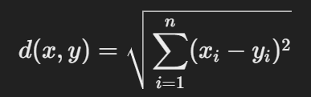

Best suited for continuous data in low-dimensional spaces.

1. **Manhattan Distance**:

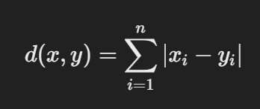

Works well for high-dimensional and sparse data.

1. **Minkowski Distance** *(Generalized form)*:

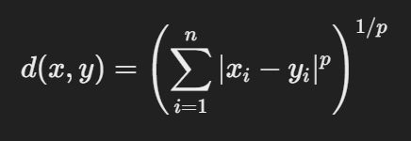

When p = 1 → **Manhattan Distance**

When p = 2 → **Euclidean Distance**

**Choosing the Value of K**

* **Small K**:
  + Leads to **high variance**.
  + Model becomes sensitive to noise.
* **Large K**:
  + Leads to **high bias**.
  + Model may miss important patterns.

**Optimal K Value:**

* Use methods like the **Elbow Method** or **Cross-Validation** to find the best K.
* Generally, **K** is chosen as an **odd number** to avoid ties in classification tasks.

**Advantages of KNN**

* **Simple and Easy to Implement**: No complex model-building phase.
* **Versatile**: Can be used for both **classification** and **regression**.
* **Non-Parametric**: No assumption about data distribution.
* **Effective for Small Datasets**: Performs well with small to medium-sized datasets.

**Disadvantages of KNN**

* **Computationally Expensive**: Requires computing the distance to all data points.
* **Memory Intensive**: Stores the entire training dataset.
* **Sensitive to Noise**: Outliers can significantly impact the results.
* **Inefficient for Large Datasets**: Becomes slow with large or high-dimensional data.

**Applications of KNN**

* **Medical Diagnosis**: Classifying diseases based on patient symptoms.
* **Recommendation Systems**: Suggesting products based on user behavior.
* **Image Recognition**: Identifying objects in images using pixel values.
* **Fraud Detection**: Detecting unusual financial transactions.
* **Market Segmentation**: Grouping similar customers for marketing strategies.

**Applications of Machine Learning Algorithms**

| **Algorithm** | **Application** | **Description** |
| --- | --- | --- |
| **Bayes Classifiers** | Spam Detection | Classify emails as spam or not spam. |
|  | Sentiment Analysis | Determine customer sentiment using reviews. |
| **Decision Trees** | Medical Diagnosis | Predict diseases using patient data. |
|  | Loan Approval | Evaluate loan applications based on financial data. |
| **Ensemble Learning** | Fraud Detection | Identify fraudulent transactions in banking. |
|  | Image Recognition | Improve accuracy in recognizing objects in images. |
| **Nearest Neighbor Methods** | Recommender Systems | Suggest products based on user preferences. |
|  | Pattern Recognition | Recognize handwritten characters. |
|  | Disease Diagnosis | Predict diseases based on symptoms and patient history. |

**Unit-5**

**Neural Network Architectures**

Neural network architectures are the building blocks of deep learning models. They consist of interconnected nodes, called neurons, which are organized in layers. Each neuron receives inputs, computes mathematical operations, and produces outputs.

**Main Components of Neural Network Architecture**

1. **Input Layer**: The input layer is the initial layer of the neural network and is responsible for receiving the input data. Each neuron in the input layer represents a feature or attribute of the input data.
2. **Hidden Layers:** Hidden layers are the intermediate layers between the input and output layers. They perform computations and transform the input data through a series of weighted connections. The number of hidden layers and the number of neurons in each layer can vary depending on the complexity of the task and the amount of data available.
3. **Neurons (Nodes):** Neurons, also known as nodes, are the individual computing units within a neural network. Each neuron receives input from the previous layer or directly from the input layer, performs a computation using weights and biases, and produces an output value using an activation function.
4. **Weights and Biases:** Weights and biases are parameters associated with the connections between neurons. The weights determine the strength or importance of the connections, while the biases introduce a constant that helps control the neuron's activation. These parameters are adjusted during the training process to optimize the network's performance.
5. **Activation Functions:** Activation functions are special mathematical formulas that add non-linear behavior to the network and allow it to learn complex patterns. Common activation functions include the sigmoid function, the rectified linear unit (ReLU), and the hyperbolic tangent (tanh) function. Each neuron applies the activation function to the weighted sum of its inputs to produce the output. Each function behaves differently and has its own characteristics. They help the network process and transform the input information, making it more suitable for capturing the complexity of real-world data. Activation functions help neurons make decisions and capture intricate relationships in the data, making neural networks powerful tools for pattern recognition and accurate predictions.
6. **Output Layer:** The output layer is the final layer of the neural network that produces the network's predictions or outputs after processing the input data. The number of neurons in the output layer depends on the nature of the task. For binary classification tasks, where the goal is to determine whether something belongs to one of two categories (e.g., yes/no, true/false), the output layer typically consists of a single neuron. For multi-class classification tasks, where there are more than two categories to consider (e.g., classifying images into different objects), the output layer consists of multiple neurons.
7. **Loss Function:** The loss function measures the discrepancy between the network's predicted output and the true output. It quantifies the network's performance during training and serves as a guide for adjusting the weights and biases. For example, if the task involves predicting numerical values, like estimating the price of a house based on its features, the mean squared error loss function may be used. This function calculates the average of the squared differences between the network's predicted values and the true values. On the other hand, if the task involves classification, where the goal is to assign input data to different categories, a loss function called cross-entropy is often used. Cross-entropy measures the difference between the predicted probabilities assigned by the network and the true labels of the data. It helps the network understand how well it is classifying the input into the correct categories.

**Types of neural network architectures**

1. **Feedforward Networks:**A feedforward neural network is a simple artificial neural network architecture in which data moves from input to output in a single direction.
2. **Singlelayer Perceptron:**A single-layer perceptron consists of only one layer of neurons. It takes inputs, applies weights, sums them up, and uses an activation function to produce an output.
3. **Multilayer Perceptron (MLP):**MLP is a type of feedforward neural network with three or more layers, including an input layer, one or more hidden layers, and an output layer. It uses nonlinear activation functions.
4. **Convolutional Neural Network (CNN):**A Convolutional Neural Network (CNN) is a specialized artificial neural network designed for image processing. It employs convolutional layers to automatically learn hierarchical features from input images, enabling effective image recognition and classification.
5. **Recurrent Neural Network (RNN):**An artificial neural network type intended for sequential data processing is called a Recurrent Neural Network (RNN). It is appropriate for applications where contextual dependencies are critical, such as time series prediction and natural language processing, since it makes use of feedback loops, which enable information to survive within the network.
6. **Long Short-Term Memory (LSTM):**LSTM is a type of RNN that is designed to overcome the vanishing gradient problem in training RNNs. It uses memory cells and gates to selectively read, write, and erase information.

In a **neural network**, a **neuron model** (also called a **node** or **artificial neuron**) is a mathematical representation inspired by biological neurons. It is the fundamental building block of artificial neural networks (ANNs).

**Basic Components of a Neuron Model**

1. **Inputs (x1​,x2​,...,xn​)**
   * Each neuron receives multiple inputs (features or outputs from previous layers).
2. **Weights (w1​,w2​,...,wn​)**
   * Each input is associated with a weight that determines its importance in the decision-making process.
3. **Weighted Sum (Net Input)**
   * The neuron calculates a weighted sum of inputs: z=∑i=1nwixi+bz = \sum_{i=1}^{n} w_i x_i + bz=i=1∑n​wi​xi​+b
   * Here, b (bias) is an additional parameter that shifts the activation function.
4. **Activation Function**
   * The weighted sum is passed through an activation function to introduce non-linearity. Common activation functions include:
     + **Sigmoid**: f(z)=11+e−zf(z) = \frac{1}{1+e^{-z}}f(z)=1+e−z1​ (used for probabilities)
     + **ReLU (Rectified Linear Unit)**: f(z)=max⁡(0,z)f(z) = \max(0, z)f(z)=max(0,z) (used in deep learning)
     + **Tanh**: f(z)=ez−e−zez+e−zf(z) = \frac{e^z - e^{-z}}{e^z + e^{-z}}f(z)=ez+e−zez−e−z​ (ranges from -1 to 1)
     + **Softmax**: Used for multi-class classification.
5. **Output (y)**
   * The activated value is either passed to the next layer or used as the final output.

**Mathematical Representation of a Neuron**

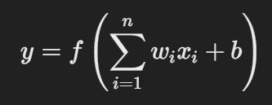

where:

* x**i**​ = input values
* w**i​** = weights
* b = bias
* f(z) = activation function
* y = output of the neuron

**Types of Neurons in Neural Networks**

* **Perceptron**: Basic linear classifier (used in early neural networks).
* **Sigmoid Neuron**: Uses the sigmoid activation function.
* **ReLU Neuron**: Uses the ReLU activation function, making deep networks efficient.
* **LSTM/GRU Neurons**: Used in recurrent neural networks (RNNs) for sequential data processing.

**Single layer perceptron**

* A single-layer perceptron is a linear classifier that makes its predictions based on a linear predictor function.
* It consists of a single layer of output nodes; in other words, it has an input layer and an output layer, with no hidden layers.
* It's used for binary classification, meaning it categorizes inputs into one of two possible outputs.
* It is only able to classify linearly separable data.

Key characteristics:

* **Linear Classifier:** It can only separate data that can be divided by a straight line (or a hyperplane in higher dimensions).
* **Simplicity:** It's the simplest type of feedforward neural network.
* **Limitations:** It cannot learn complex, non-linear patterns, such as the XOR function.

  The perceptron consists of 4 parts.

* **Input value or One input layer:** The input layer of the perceptron is made of artificial input neurons and takes the initial data into the system for further processing.
* **Weights and Bias:**  
  **Weight:** It represents the dimension or strength of the connection between units. If the weight to node 1 to node 2 has a higher quantity, then neuron 1 has a more considerable influence on the neuron.  
  **Bias:** It is the same as the intercept added in a linear equation. It is an additional parameter which task is to modify the output along with the weighted sum of the input to the other neuron.
* **Net sum:** It calculates the total sum.
* **Activation Function:** A neuron can be activated or not, is determined by an activation function. The activation function calculates a weighted sum and further adding bias with it to give the result.

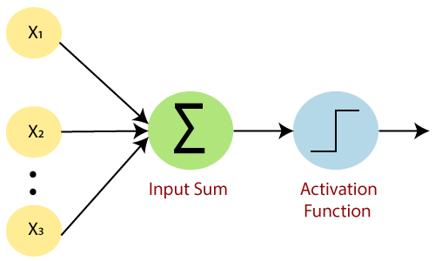

How does it work?

The perceptron works on these simple steps which are given below:

**a.** In the first step, all the inputs x are multiplied with their weights **w**.

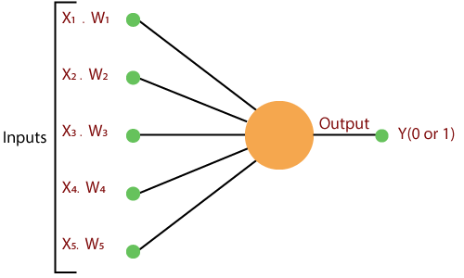

**b.** In this step, add all the increased values and call them the **Weighted sum**.

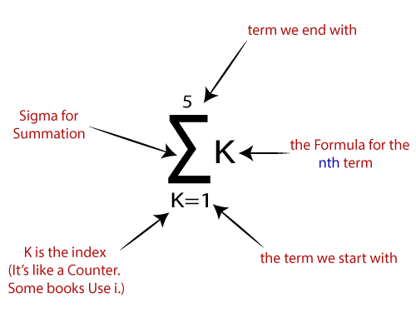

**c.** In our last step, apply the weighted sum to a correct **Activation Function**.

**For Example:**

A Unit Step Activation Function

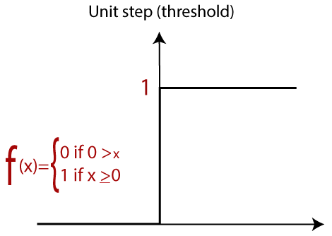

**Multi-Layer Perceptron Learning**

**Multi-Layer Perceptron (MLP)** is an artificial neural network widely used for solving classification and regression tasks.

MLP consists of fully connected dense layers that transform input data from one dimension to another. It is called *“multi-layer”* because it contains an input layer, one or more hidden layers, and an output layer. The purpose of an MLP is to model complex relationships between inputs and outputs, making it a powerful tool for various machine learning tasks.

**Key Components of Multi-Layer Perceptron (MLP)**

* **Input Layer**: Each neuron (or node) in this layer corresponds to an input feature. For instance, if you have three input features, the input layer will have three neurons.
* **Hidden Layers**: An MLP can have any number of hidden layers, with each layer containing any number of nodes. These layers process the information received from the input layer.
* **Output Layer**: The output layer generates the final prediction or result. If there are multiple outputs, the output layer will have a corresponding number of neurons.

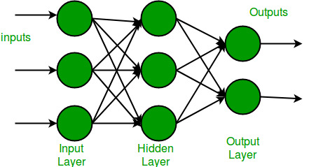

**Working of Multi-Layer Perceptron**

**Step 1: Forward Propagation**

In **forward propagation**, the data flows from the input layer to the output layer, passing through any hidden layers. Each neuron in the hidden layers processes the input as follows:

1. **Weighted Sum**: The neuron computes the weighted sum of the inputs:
   * z=∑iwixi+b*z*=∑*i*​*wi*​*xi*​+*b*
     + Where:
       - xi*xi*​​ is the input feature.
       - wi*wi*​​ is the corresponding weight.
       - b*b* is the bias term.
2. **Activation Function**: The weighted sum z is passed through an activation function to introduce non-linearity. Common activation functions include:
   * **Sigmoid**

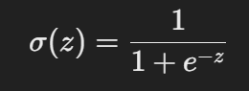

* + **ReLU (Rectified Linear Unit)**:

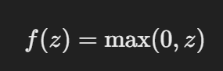

* + **Tanh (Hyperbolic Tangent)**:

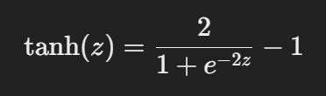

**Step 2: Loss Function**

Once the network generates an output, the next step is to calculate the loss using a loss function. In supervised learning, this compares the predicted output to the actual label.

For a classification problem, the commonly used **binary cross-entropy** loss function is:

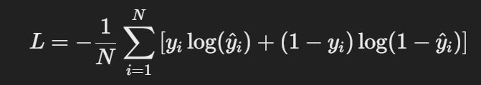

where:

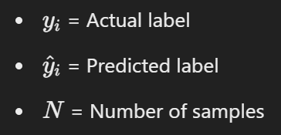

For regression problems, the **mean squared error (MSE)** is often used:

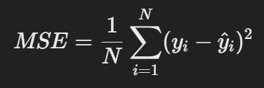

**Step 3: Backpropagation**

The goal of training an MLP is to minimize the loss function by adjusting the network’s weights and biases. This is achieved through **backpropagation**:

1. **Gradient Calculation**: The gradients of the loss function with respect to each weight and bias are calculated using the chain rule of calculus.
2. **Error Propagation**: The error is propagated back through the network, layer by layer.
3. **Gradient Descent**: The network updates the weights and biases by moving in the opposite direction of the gradient to reduce the loss:

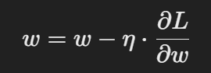​

where:

* + - w is the weight.
    - η is the learning rate.
    - ∂L/∂*w*​​ is the gradient of the loss function with respect to the weight.

**Step 4: Optimization**

MLPs rely on optimization algorithms to iteratively refine the weights and biases during training. Popular optimization methods include:

* **Stochastic Gradient Descent (SGD)**: Updates the weights based on a single sample or a small batch of data:

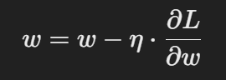​

* **Adam Optimizer**: An extension of SGD that incorporates momentum and adaptive learning rates for more efficient training:

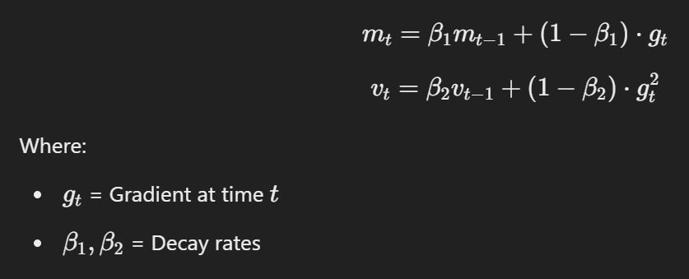

**Learning Rules in Neural Networks**

A **learning rule** (or **learning algorithm**) in a neural network defines how the network updates its weights based on the input data and error. The goal is to improve the network’s performance by minimizing the error over time.

**1. What is Backpropagation?**

Backpropagation (**backward propagation of errors**) is a supervised learning algorithm used to train artificial neural networks. It helps adjust the network's weights by propagating the error backward from the output layer to the input layer.

**2. Generalized Delta Rule (Gradient Descent with Backpropagation)**

The **Generalized Delta Rule** extends the **Delta Rule** for multi-layer neural networks. It uses **gradient descent** to minimize the error function by adjusting the weights.

**Steps of Backpropagation**

1. **Forward Pass**
   * Compute the output of the network layer by layer.
   * Apply the activation function to each neuron.
2. **Calculate Error**
   * Compare the predicted output with the actual output using an error function:

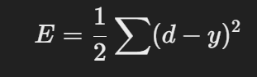

* + where:
    - d = desired output
    - y = actual output

1. **Backward Pass (Weight Update using the Generalized Delta Rule)**
   * Compute the gradient of the error with respect to each weight.
   * Update the weights using **gradient descent**:

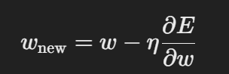

where:

* + - η = learning rate
    - ∂E /∂w​ = derivative of error w.r.t weight

1. **Repeat until convergence**
   * The process continues until the error reaches a minimal threshold.

**Neural Network Applications**

**A. Image & Video Processing**

✅ **Face Recognition** – Used in security and social media.  
✅ **Object Detection** – Autonomous vehicles use CNNs for detecting objects.  
✅ **Medical Imaging** – Used in diagnosing diseases from X-rays and MRIs.

**B. Natural Language Processing (NLP)**

✅ **Speech Recognition** – Virtual assistants like Siri, Alexa.  
✅ **Machine Translation** – Google Translate uses deep learning.  
✅ **Chatbots** – AI-based customer support systems.

**C. Business & Finance**

✅ **Stock Market Prediction** – Analyzing trends using Recurrent Neural Networks (RNNs).  
✅ **Fraud Detection** – Identifying fraudulent transactions in banking.

**D. Healthcare**

✅ **Drug Discovery** – AI models help in pharmaceutical research.  
✅ **Personalized Medicine** – Predicting treatment plans based on patient data.

**E. Robotics & Automation**

✅ **Self-Driving Cars** – Neural networks help vehicles recognize road signs and obstacles.  
✅ **Industrial Automation** – AI-driven robots in manufacturing.

**What is Clustering?**

Clustering is an **unsupervised learning** technique that groups similar data points into clusters.

The algorithm **finds patterns and structures** in the data without predefined labels.

🔹 **Key Idea:**

* Similar data points are grouped together.
* Each cluster contains objects that are **more similar to each other** than to those in other clusters.

**K-Means Algorithm**

K-Means is an **unsupervised machine learning algorithm** used for **clustering** data points into groups based on similarity. It minimizes the variance within clusters by assigning each data point to the nearest cluster center.

**Steps in K-Means Algorithm**

1. **Choose the number of clusters (K)**.
2. **Initialize K centroids (randomly or using a specific method).**
3. **Assign each data point to the nearest centroid** using the **Euclidean distance formula**:

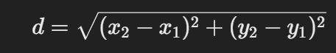

1. **Update the centroids** by computing the mean of all points assigned to each cluster.
2. **Repeat Steps 3 and 4** until centroids stop changing or reach a predefined number of iterations.

**Example of K-Means Clustering**

**Problem Statement:**

Suppose we have the following dataset representing the annual income (in ₹1000s) and spending score of customers in a shopping mall:

| **Customer** | **Income (₹1000s)** | **Spending Score** |
| --- | --- | --- |
| A | 15 | 39 |
| B | 16 | 81 |
| C | 28 | 50 |
| D | 45 | 12 |
| E | 55 | 60 |
| F | 60 | 20 |

**Applying K-Means (K=2)**

**Step 1**: Select **K=2** (dividing customers into 2 groups).

**Step 2**: Initialize **two random centroids**.

**Step 3**: Assign each customer to the **nearest centroid**.

**Step 4**: Compute **new centroids** by averaging the values in each cluster.

**Step 5**: Repeat the process until centroids remain unchanged.

**Final Result:** Customers are grouped into **two clusters** (High Income vs. Low Income).

**Applications of K-means Clustering**

* **Customer Segmentation:** Grouping customers based on purchasing behavior for targeted marketing.
* **Anomaly Detection:** Identifying fraudulent transactions or unusual patterns in financial data.
* **Medical Diagnosis:** Classifying diseases by analyzing patient symptoms and medical data.
* **Document Categorization:** Organizing large volumes of text data into topics or categories.
* **Image Segmentation:** Dividing an image into meaningful regions for object detection and recognition.

**Advantages of K-Means Clustering**

* **No Need for Labeled Data:** Works effectively without requiring labeled data for training.
* **Identifies Hidden Patterns:** Uncovers natural groupings and relationships in data.
* **Scalable:** Efficient for large datasets with faster convergence.
* **Flexible:** Adapts to different types of data distributions.
* **Fast Convergence:** Performs quick clustering compared to other algorithms.

**Disadvantages of K-Means Clustering**

* **Sensitive to Initial Centroids:** Poor centroid initialization can lead to suboptimal clustering.
* **Non-Spherical Clusters:** Struggles to cluster data with irregular shapes or densities.
* **Manual Selection of K:** Requires choosing the number of clusters, often using the Elbow Method.
* **Affected by Outliers:** Outliers can distort centroids and lead to inaccurate clusters.
* **Uniform Cluster Sizes:** Assumes clusters are of similar size, which may not always be true.

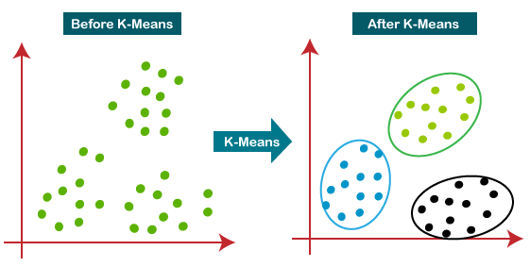

**Association Rules**

**Association Rule Mining** is used to discover interesting relationships or patterns among large sets of data. It identifies rules that explain how items are related within a dataset, often used in market basket analysis.

**Example:** If a customer buys **bread** and **butter**, they are likely to buy **milk**.  
**Rule:** {Bread, Butter} → {Milk}

**Components of Association Rules:**

* **Antecedent (LHS)** → The item(s) on the left-hand side of the rule (e.g., Bread, Butter).
* **Consequent (RHS)** → The item(s) on the right-hand side of the rule (e.g., Milk).

**Key Metrics for Evaluating Association Rules:**

1. **Support:**

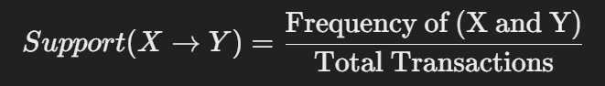

It shows how often the rule applies within the dataset.

1. **Confidence:**

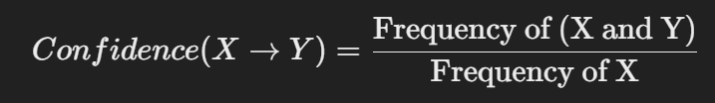

It measures how often the rule has been correct.

1. **Lift:**

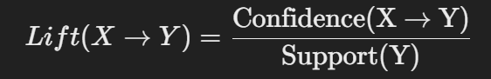

Lift indicates how much more likely the consequent is to occur with the antecedent compared to random chance.

**Algorithm for Association Rule Mining:**

* **Apriori Algorithm** → Identifies frequent itemsets using support and confidence thresholds.
* **FP-Growth Algorithm** → A faster and more efficient algorithm using a tree structure.

**Applications of Association Rules:**

* Market Basket Analysis for retail stores.
* Recommendation systems (e.g., Amazon’s "Customers who bought this also bought...").
* Fraud detection in financial institutions.